QPAY Certification
Merchant Evidence — Certification Guidelines and UI Best Practices
This document is our response to the QPAY “Certification Guidelines and UI Best Practices”. For each of the four required areas it describes how the merchant site implements the requirement and provides evidence: code snippets from the production system, transaction records from the certification test runs, and automated test results.

Merchant details
Merchant ID | cbq_gulf
Bank ID | QPAYPG02
Merchant site (parent portal) | https://newrest.qposs.me
Payment return URL | https://spa.astraqatar.com/api/v1/parent/qpay/return
Purpose of payments | Parents top up their child’s school canteen card (student wallet).
Currency | QAR (ISO 4217 numeric 634)
Integration | QCB QPay EZ-Connect, Integration Guide v1.8
Functions implemented | Redirect Pay Web (Action 0), Inquiry (Action 14), Refund (Action 6)
Site language | English (Lang=En is sent on every request)
Document date | 4 October 2026

Compliance summary
# | Requirement | Status | Evidence
1 | General web site requirements | Implemented | Section 1: domain, SSL certificate, sign-in guard, language
2 | Transaction response / status handling | Implemented | Section 2: result page shows PUN, amount, status, date & time
3 | Broken transaction handling | Implemented | Section 3: duplicate-payment block, scheduled Inquiry after 20 minutes
4 | Tampered transaction handling | Implemented | Section 4: SecureHash check, posted status dropped, Inquiry decides
— | Refund | Implemented | Section 5: full refund via Action 6

1. General web site requirements

1.1 Domain name
The merchant site is reached by a domain name, not an IP address: https://newrest.qposs.me (parent portal). The QPAY return endpoint is on https://spa.astraqatar.com.

1.2 SSL (HTTPS)
All integrated pages are served over HTTPS only. Plain HTTP requests are permanently redirected (HTTP 301) to HTTPS.
Certificate subject | CN=newrest.qposs.me
Issuer | Let’s Encrypt (CN=YE2), a publicly trusted CA
Valid | 19 Sep 2026 – 18 Dec 2026 (renewed automatically)
Protocol / cipher | TLS 1.3, CHACHA20-POLY1305 (256-bit)
HTTP → HTTPS | 301 Moved Permanently

1.3 Direct access to integrated pages is blocked
A parent must sign in before any page of the portal opens, including the top-up page and the payment result page. A visitor who opens a link directly (for example a bookmarked result page) is sent to the sign-in page and, after signing in, back to the page they asked for. This applies to every page except sign-in and password reset.
parent_portal/src/router/index.js — every page requires sign-in
router.beforeEach((to) => {
if (to.meta.public) return true
// Already signed in: skip sign-in and go where the parent was heading.
if (to.meta.guest) return session.signedIn ? safeRedirect(to.query.redirect) || { name: 'home' } : true
// Keep where the parent was going (e.g. the QPay result page) for after sign-in.
if (!session.signedIn) return { name: 'login', query: to.fullPath !== '/' ? { redirect: to.fullPath } : {} }
return true
})
Client side: the portal’s router sends unauthenticated visitors to the sign-in page.
The server enforces the same rule. Every data endpoint behind the portal (children, balances, starting a top-up, reading a top-up result) requires a valid parent access token; without one the API answers 401. A parent can only see top-ups for their own children; any other payment reference returns 404.
app/Http/Middleware/AuthenticateParent.php — server-side guard
public function handle(Request $request, Closure $next): Response
{
$guardian = Auth::guard('parent')->user();
if (! $guardian instanceof Guardian
|| ! $guardian->currentAccessToken() instanceof PersonalAccessToken
|| ! $guardian->isActive()) {
return response()->json(['success' => false, 'message' => 'Please sign in again.'], 401);
}

return $next($request);
}

app/Actions/V1/Parent/GetTopupAction.php
// A top-up the parent started, by its payment reference.
// Only payments for this parent's own children; anyone else's is a 404.
return QpayTransaction::with('account:id,name')
->where('pun', $pun)
->where('type', QpayTransaction::TYPE_PAYMENT)
->whereIn('account_id', $guardian->students()->pluck('accounts.id'))
->firstOrFail();
The only endpoint reachable without a token is the QPAY return URL. It is authenticated by QPAY’s SecureHash instead (see Section 4), and it only redirects the browser to the result page, which itself requires sign-in.

1.4 Supported languages
The merchant site supports English. The parent portal is shown in English throughout, and every request to QPAY carries Lang=En, so the QPAY payment pages appear in the same language as the rest of the payment cycle. The language is stored on each transaction, and Inquiry and Refund requests reuse it.
app/Actions/V1/Parent/StartTopupAction.php / StartPaymentAction.php
$lang = $request->validated('lang') === 'Ar' ? 'Ar' : 'En';
...
'lang' => $lang === 'Ar' ? 'Ar' : 'En', // saved on the transaction, reused for Inquiry/Refund

2. Transaction response / status handling
After payment, QPAY returns the parent’s browser to our return URL. The response is verified (Section 4), recorded, and the parent is redirected to the result page. That page is shown for both successful and failed transactions and displays the four required fields:
QPAY requirement | Shown on the result page as | Source
1. PUN (Payment Unique Number) | “Payment reference” | The PUN we generated and sent to QPAY
2. Transaction amount | Large amount at the top, e.g. “QAR 100.00” | Amount of the transaction
3. Transaction status | Title + status tag: “Payment successful / Paid” or “Payment failed / Failed” | Status from the verified QPAY response
4. Transaction date & time | “Date & time” | Time the result was received

The page also shows the QPAY confirmation ID and the new card balance. On a failed transaction it shows QPAY’s message and a “Try again” button. While a result is still being confirmed it shows “Confirming your payment… Please don’t pay again.” and refreshes automatically.
parent_portal/src/views/TopupResultView.vue — result page (template, abridged)
<h1 class="pp-receipt__title">{{ view.title }}</h1> <!-- "Payment successful" / "Payment failed" -->
<p class="pp-receipt__amount"><small>{{ school.currency.code }}</small>{{ amount(topup.amount) }}</p>

<dl class="pp-receipt__fields">
<div><dt>Date &amp; time</dt><dd>{{ dateTime(topup.completed_at || topup.created_at) }}</dd></div>
<div><dt>Status</dt><dd><span class="pp-tag">{{ view.tag[1] }}</span></dd></div> <!-- Paid / Failed -->
<div><dt>Payment method</dt><dd>{{ paidWith }}</dd></div>
<div><dt>Payment reference</dt><dd>{{ topup.pun }}</dd></div> <!-- PUN -->
<div><dt>QPay confirmation</dt><dd>{{ topup.confirmation_id || 'Not received yet' }}</dd></div>
</dl>

TopupResultView.vue — status wording
success: { title: 'Payment successful', tag: 'Paid' },
failed: { title: 'Payment failed', tag: 'Failed',
msg: t.message ? `${t.message} No money was taken.` : 'No money was taken. You can try again.' },
pending: { title: 'Confirming your payment…', tag: 'Confirming',
msg: "Please don't pay again. This usually takes a few seconds." },

Screenshots of the result page (parent portal, live certification run on 21 Oct 2026, QAR 1.00 each):
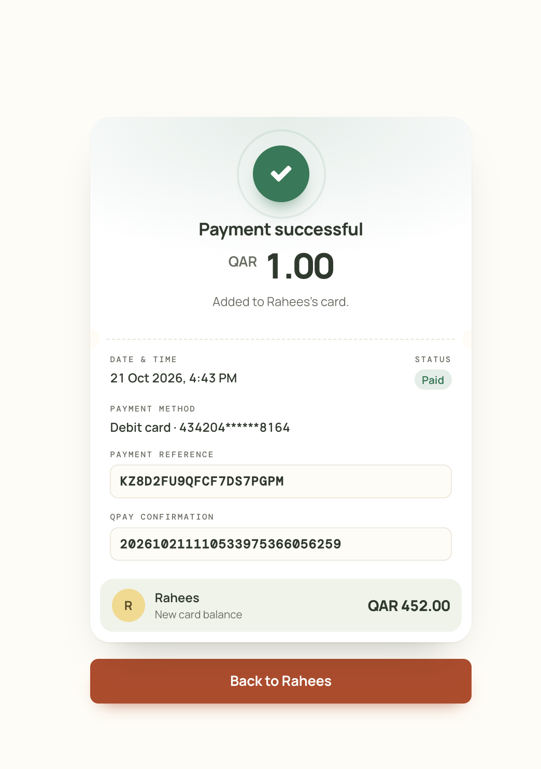  Figure 1 — Successful payment  KZ8D2FU9QFCF7DS7PGPM · 4:43 PM | 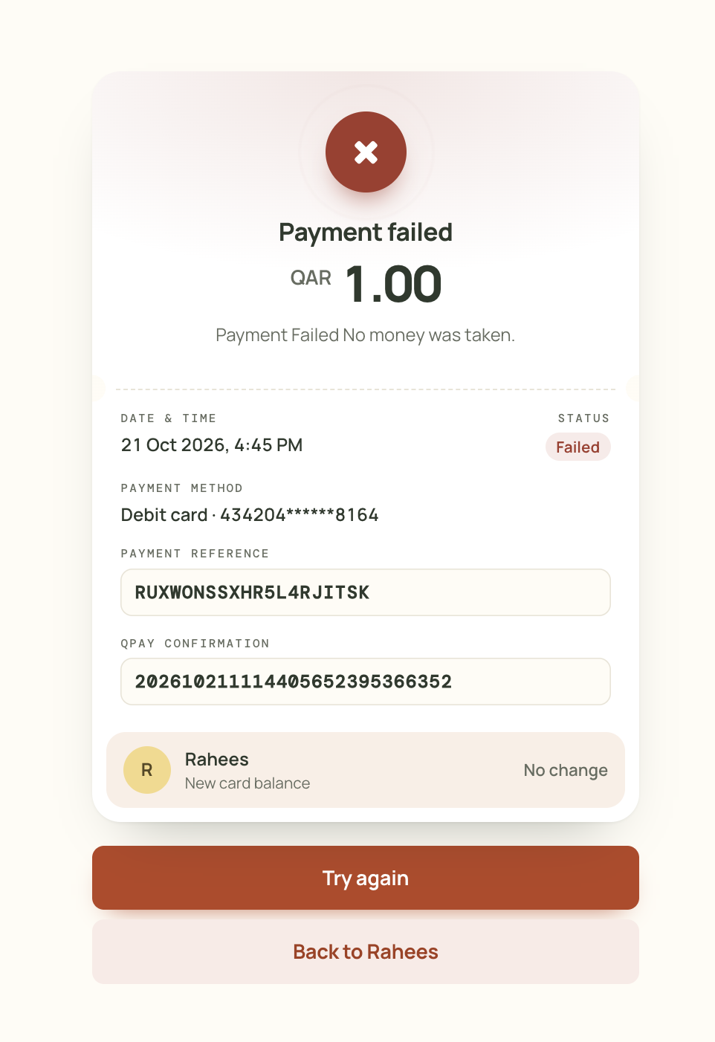  Figure 2 — Failed payment  RUXWONSSXHR5L4RJITSK · 4:45 PM
Both pages show the four required fields: payment reference (PUN), amount, status, and date & time. They also show the payment method, the QPAY confirmation ID and the new card balance. The failed page shows “Try again”.
Transactions from the certification test runs (merchant cbq_gulf, times in Qatar time, AST). All 29 top-up payments that reached a final status are listed: 11 successful and 18 failed. Each was shown on the result page with its PUN, amount, status and date & time; successful payments as “Payment successful / Paid” with the card credited, failed payments as “Payment failed / Failed” with the card untouched. Note: the result page shows the time in the viewer’s own browser time zone; the screenshots above were taken on a browser set to UTC+5:30, which is why they read 4:43 PM and 4:45 PM for the payments recorded below at 14:13 and 14:15 AST.
Successful transactions (11)
PUN | Amount | QPAY status  received via | QPAY confirmation ID  card | Result received (AST)
KNJYTXO18M0NCUJDTP7R | QAR 50.00 | 0000 Payment Processed Successfully  Payment response (browser return) | 202609190657488741239336456  Card 434204******8164 | 19 Sep 2026 21:59
AFCFUTZ8ZHM2LV6KPNHT | QAR 100.00 | 0000 Payment Processed Successfully  Payment response (browser return) | 202609190702586614681889012  Card 434204******8164 | 19 Sep 2026 22:03
NDGJ4O5V1KLIERSMQB3C | QAR 100.00 | 0000 Payment Processed Successfully  Payment response (browser return) | 202609190746231973432576236  Card 434204******8164 | 19 Sep 2026 22:47
5AQAHR7P1BJJMBRCR0KX | QAR 100.00 | 0000 Payment Processed Successfully  Payment response (browser return) | 202609190812199084330424339  Card 434204******8164 | 19 Sep 2026 23:13
RDCN4CIJUR4UNVYIBR4D | QAR 200.00 | 0000 Payment Processed Successfully  Payment response (browser return) | 202609200711069621310491937  Card 434204******8164 | 20 Sep 2026 10:11
X2GQSIWYYHYBTFGWKXQP | QAR 100.00 | 0000 Payment Processed Successfully  Payment response (browser return) | 202609200459261181925478954  Card 434204******8164 | 20 Sep 2026 20:00
XKVNTB59J8UASCMFZRXL | QAR 200.00 | 0000 Payment Processed Successfully  Payment response (browser return) | 202609210511140161778541829  Card 434204******8164 | 21 Sep 2026 08:12
LMCVFCE3ZJ4MEASOEC8H | QAR 100.00 | 0000 Payment Processed Successfully  Payment response (browser return); later refunded in full (Section 5) | 202609210742019978510559653  Card 434204******8164 | 21 Sep 2026 10:44
ZGXJ1XWY4JPIT6XZJ17B | QAR 100.00 | 0000 Payment Processed Successfully  Payment response (browser return) | 202609210225551423885226278  Card 434204******8164 | 21 Sep 2026 17:26
KZ8D2FU9QFCF7DS7PGPM | QAR 1.00 | 0000 Payment Processed Successfully  Payment response (browser return) | 202610211110533975366056259  Card 434204******8164 | 21 Oct 2026 14:13
FPNCIVPLLUJW1TR9J3OG | QAR 50.00 | 0000 Payment Processed Successfully  Payment response (browser return) | 202610211137589136932620892  Card 434204******8164 | 21 Oct 2026 14:38

Failed transactions (18)
PUN | Amount | QPAY status  received via | QPAY confirmation ID  card | Result received (AST)
TJFCRMKLIZADKDCMMCBQ | QAR 100.00 | 3000 Payment Failed  Payment response (browser return) | 202609200432279997714493892  Card 434204******8164 | 20 Sep 2026 07:36
XEZPX2BKXUPSYBCMRNMR | QAR 200.00 | 2996 Payment Cancelled  Payment response (browser return) | 202609200446242068428946577  No card entered | 20 Sep 2026 19:51
V4XTCZO3TGCVXC4KNTTB | QAR 100.00 | 3000 Payment Failed  Payment response (browser return) | 202609200451597166578703267  Card 416639******0368 | 20 Sep 2026 19:56
9YWZGEMHQ5YPAMG4PYIX | QAR 200.00 | 3000 Payment Failed  Payment response (browser return) | 202609200456549407908751196  Card 471354******4772 | 20 Sep 2026 19:57
MNZYA1Y9PXGNPASVXMRL | QAR 50.00 | 3000 Payment Failed  Payment response (browser return) | 202609200458268713985375585  Card 471354******4772 | 20 Sep 2026 19:59
VTQZAKFVMKPBZWHVF4TU | QAR 100.00 | 2996 Payment Cancelled  Payment response (browser return) | 202609210706174873319935784  No card entered | 21 Sep 2026 10:06
LU8L8SN3MYYDDSD8YJ1F | QAR 100.00 | 2996 Payment Cancelled  Payment response (browser return) | 202609210802204775856423849  No card entered | 21 Sep 2026 11:05
GDKVJYHT1MODYZKEABQJ | QAR 50.00 | 8106 Transaction not found.  Inquiry (Action 14) | None (not received by QPAY)  No card entered | 22 Sep 2026 09:40
R4XSJPNJNP60KRVWSKPI | QAR 100.00 | 2992 Payment Status-Time out.  Inquiry (Action 14) | 202609210725200803103943422  No card entered | 22 Sep 2026 09:40
VGA8UAOB4DBYE0TYYTLQ | QAR 100.00 | 2992 Payment Status-Time out.  Inquiry (Action 14) | 202609211136291751452181114  No card entered | 22 Sep 2026 09:40
YSGWJCMGRA3I0CA6CRU5 | QAR 100.00 | 2992 Payment Status-Time out.  Inquiry (Action 14) | 202609210630279825892554046  No card entered | 22 Sep 2026 09:45
4BFAAD2ANSSSJPPJNAFA | QAR 10.00 | 2992 Payment Status-Time out.  Inquiry (Action 14) | 202609230833079458378488389  No card entered | 23 Sep 2026 11:55
U3PBUAYILNVXYTPD3ST0 | QAR 1.00 | 8106 Transaction not found.  Inquiry (Action 14) | None (not received by QPAY)  No card entered | 21 Oct 2026 14:10
ATFH1BQWVNZHRINI3JAK | QAR 1.00 | 8106 Transaction not found.  Inquiry (Action 14) | None (not received by QPAY)  No card entered | 21 Oct 2026 14:10
RURWV4YOSQ0H62IL8TKI | QAR 1.00 | 8106 Transaction not found.  Inquiry (Action 14) | None (not received by QPAY)  No card entered | 21 Oct 2026 14:10
B1S4J2TAD0TVFVC9JNAU | QAR 1.00 | 8106 Transaction not found.  Inquiry (Action 14) | None (not received by QPAY)  No card entered | 21 Oct 2026 14:10
RUXWONSSXHR5L4RJITSK | QAR 1.00 | 3000 Payment Failed  Payment response (browser return) | 202610211114405652395366352  Card 434204******8164 | 21 Oct 2026 14:15
TWMQVARQUQT01GFIF6UE | QAR 1.00 | 3000 Payment Failed  Payment response (browser return) | 202610211135538318409341112  Card 471354******4772 | 21 Oct 2026 14:37
Failure codes seen: 3000 Payment Failed (card payment declined); 2996 Payment Cancelled (cancelled on the QPAY page); 2992 Payment Status-Time out (payment timed out at QPAY; settled by Inquiry); 8106 Transaction not found (QPAY has no record of the payment; settled by Inquiry after 20 minutes). No money was taken on any failed transaction.

3. Broken transaction handling
Every payment is saved as pending before the parent is sent to QPAY. If no result reaches us (browser closed, device switched off, connection reset), the payment stays pending and is handled as follows:
- No duplicate payment. While a payment for the same student is still pending, the merchant site refuses to start a new one. The parent sees: “A top-up started at 03:00 PM is still being confirmed. You can try again after 03:21 PM.”, with a countdown.
- Inquiry after 20 minutes. Once the pending payment is 20 minutes old, the Inquiry API (Action 14) is called for it. A scheduled job runs every 5 minutes and inquires every pending payment that is at least 20 minutes old, then again every 20 minutes until QPAY gives a final status. The same Inquiry is also made immediately when the parent tries to pay again after the 20 minutes.
- Act on the Inquiry result. Successful → the card is credited (the service is delivered). Failed or “transaction not found” (8106) → the payment is closed as failed and the parent may pay again.
- Never decided on the parent’s word. The parent’s “Cancel this payment” button and the school office’s “Release” button both call Inquiry first, and neither is available inside the first 20 minutes.
Example (as in the guideline): a payment started at 03:00 PM with no result blocks new payments until 03:21 PM. At that point the Inquiry function is called and the payment is settled from QPAY’s answer.
app/Actions/QPay/StartPaymentAction.php — duplicate-payment block (abridged)
/** QPay certification: a payment without a result blocks new ones for this long before it is inquired. */
public const BROKEN_AFTER_MINUTES = 20;

private function guardAgainstBrokenPayment(Account $student): void
{
$pending = QpayTransaction::where('account_id', $student->id)
->where('type', QpayTransaction::TYPE_PAYMENT)
->where('gateway', QpayTransaction::GATEWAY_QPAY)
->where('status', QpayTransaction::STATUS_PENDING)
->oldest('id')->get();

foreach ($pending as $transaction) {
$retryAt = $transaction->created_at->copy()->addMinutes(self::BROKEN_AFTER_MINUTES)->addMinute();

if (now()->lt($retryAt)) {
throw new TopupInProgressException('A top-up started at '.$transaction->created_at->format('h:i A')
.' is still being confirmed. You can try again after '.$retryAt->format('h:i A').'.', $retryAt, $transaction->pun);
}

(new InquireAction())->execute($transaction); // QPay Inquiry, Action 14

if ($transaction->refresh()->isPending()) {
throw new TopupInProgressException('We are still confirming an earlier top-up with QPay. ...');
}
}
}

routes/console.php — scheduled job (cron)
// QPay certification: student card top-ups with no result are inquired after 20 minutes.
Schedule::command('qpay:inquire-pending')->everyFiveMinutes()->withoutOverlapping();

app/Console/Commands/Student/QPayInquirePendingCommand.php — qpay:inquire-pending (abridged)
$cutoff = now()->subMinutes(StartPaymentAction::BROKEN_AFTER_MINUTES); // 20 minutes

$pending = QpayTransaction::where('type', QpayTransaction::TYPE_PAYMENT)
->whereIn('status', QpayTransaction::STATUSES_AWAITING_RESULT)
->where('created_at', '<=', $cutoff)
->where(fn ($q) => $q->whereNull('last_inquired_at')->orWhere('last_inquired_at', '<=', $cutoff))
->get();

foreach ($pending as $transaction) {
(new InquireAction())->execute($transaction);
}

app/Actions/QPay/InquireAction.php — acting on the Inquiry result (abridged)
$values = (new QPayClient(QPaySettings::current()))->inquire($transaction->pun, $transaction->lang ?: 'En');
$status = $values['Status'] ?? '';

if ($status === QPayClient::NOT_FOUND) { // 8106: QPay never received it
// final only once the payment is 20+ minutes old
(new SettleAction())->execute($transaction, ['status' => $status, ...]); // -> failed
} elseif ($status === QPayClient::SUCCESS && filled($values['OriginalStatus'] ?? null)) {
(new SettleAction())->execute($transaction, [
'status' => $values['OriginalStatus'], // 0000 -> credited, otherwise failed
'amount' => $values['Amount'] ?? null,
'confirmation_id' => $values['OriginalConfirmationID'] ?? null,
], $values);
}
// any other answer: left pending and asked again on the next run

Settlement is idempotent: the transaction row is locked and a payment that already has a final result is never changed again. A browser return and an Inquiry arriving at the same moment can therefore never credit the card twice.
Broken transaction from the certification test runs (times in AST):
PUN | Started | Result received from browser | Inquiry sent | Inquiry result → action
4BFAAD2ANSSSJPPJNAFA (QAR 10.00) | 23 Sep 2026 11:33:07 | None (broken) | 23 Sep 2026 11:55:10 | 2992 Payment Status-Time out → closed as failed, parent unblocked

4. Tampered transaction handling
Every response from QPAY carries a SecureHash. We compute the expected hash ourselves (SHA-256 of the merchant secret key followed by the parameter values in ascending order of parameter name, as in the Integration Guide) and compare it with the one received using a constant-time comparison.
- Payment response (browser return): if the SecureHash is missing or does not match, the response is treated as tampered. The status in it is dropped, the transaction is flagged as tampered (tampered_at), and an Inquiry is sent to QPAY. Only the Inquiry result decides the outcome.
- Inquiry and Refund responses (server to server): the SecureHash is checked the same way. An unsigned or tampered answer is rejected and the payment stays pending until a correctly signed answer arrives.
- Amount check: even on a correctly signed success, the amount QPAY reports must equal the amount we requested; otherwise the payment is held for manual review and nothing is credited.
app/Services/Payment/QPayClient.php — SecureHash generation and verification
/** SHA-256 over secret + values ordered by parameter name. */
public static function hash(string $secretKey, array $params): string
{
unset($params['SecureHash']);
ksort($params, SORT_STRING);

return hash('sha256', $secretKey.implode('', array_map(fn ($value) => (string) $value, $params)));
}

/** Whether a parsed response was signed with this merchant's secret key. */
public function verify(array $parsed): bool
{
if (! $this->settings->secretKey || ! filled($parsed['hash'] ?? null)) {
return false;
}
$received = strtolower((string) $parsed['hash']);
foreach (self::responseHashes($this->settings->secretKey, $parsed['values']) as $expected) {
if (hash_equals($expected, $received)) {
return true;
}
}
return false;
}

app/Actions/QPay/HandleReturnAction.php — tampered response handling
$client = new QPayClient($settings);

if (! $client->verify($parsed)) {
Log::warning('QPay return failed the secure hash check; inquiring instead', ['pun' => $pun]);
QPayApiLog::answered($log, $parsed, 'The result failed the secure hash check and was dropped; QPay was inquired instead.');
$transaction->forceFill(['tampered_at' => now()])->save();
(new InquireAction())->execute($transaction); // Inquiry decides the real status

return $transaction->refresh();
}

// Hash verified: settle with the status QPay sent
return (new SettleAction())->execute($transaction, [ 'status' => (string) ($values['Status'] ?? ''), ... ]);

QPayClient::backToBack() — Inquiry / Refund responses must also be signed
$parsed = self::parseResponse(trim($response->body()));
if (! $this->verify($parsed)) {
Log::error('QPay response failed the secure hash check', ['operation' => $operation, 'body' => $response->body()]);
throw new QPayException('The payment service response could not be verified.');
}

Automated test proving the behaviour: a response claiming success but signed with a wrong hash is dropped, an Inquiry (Action 14) with the correct SecureHash is sent for that PUN, the transaction is flagged as tampered, and the Inquiry’s answer (failed) is what is recorded. The card is not credited.
tests/Feature/Student/QPayTopupTest.php
it('drops a tampered result and believes only the inquiry', function (): void {
$transaction = qpayStart($this, 100);
Http::fake(fn () => Http::response(qpayInquiryResponse($transaction, ['OriginalStatus' => '3000'])));

// Claims success, but the hash is not QPay's.
qpayPostReturn($this, qpaySigned(qpayPaymentResponse($transaction), str_repeat('a', 64)));

Http::assertSent(fn (Request $request) => $request['Action'] === '14' && $request['OriginalPUN'] === $transaction->pun);

expect($transaction->refresh()->tampered_at)->not->toBeNull()
->and($transaction->status)->toBe('failed')
->and(qpayBalance($this))->toBe(0.0);
});

5. Refund
School office staff can refund a successful top-up from the back office. The full amount is refunded (Action 6, OriginalTransactionPaymentUniqueNumber_1 = the payment’s PUN) under a new PUN. The refund is recorded before QPAY is called, and the card balance is reduced only when QPAY accepts it (0000, or 5002 pending). The response SecureHash is verified as in Section 4.
Refund PUN | Original PUN | Amount | QPAY status | Date & time (AST)
HSDT3WKLLDNRU8VZCTJX | LMCVFCE3ZJ4MEASOEC8H | QAR 100.00 | 0000 Refund transaction processed successfully | 23 Sep 2026 09:22

Appendix — automated test results
The QPAY integration is covered by automated tests that run on every change. Latest run, 4 October 2026: QPAY suites 41 passed (252 assertions); parent portal access suite 17 passed (162 assertions); no failures. The SecureHash unit tests use the worked examples from Appendix D of the Integration Guide.
Area | Test
SecureHash | signs a payment request exactly as the guide
SecureHash | signs an inquiry and a refund request exactly as the guide
SecureHash | verifies the guide's payment, inquiry and refund responses
Response handling | credits the card exactly once for a signed successful result
Response handling | records a declined payment as failed without touching the card
Response handling | shows a parent only their own children's top-ups
Broken transaction | blocks a second top-up while the first has no result, then inquires it after 20 minutes
Broken transaction | settles a broken transaction from the scheduled inquiry
Broken transaction | will not release a payment the parent may still be making
Broken transaction | cancels a payment QPay confirms it never received, and frees the card for a new one
Broken transaction | credits the card instead when QPay says the payment went through
Tampered transaction | drops a tampered result and believes only the inquiry
Tampered transaction | refuses an inquiry answer that is not signed by QPay
Tampered transaction | parks a payment whose captured amount differs for review
Refund | refunds a top-up in full and takes it off the card
Access control | is a 404 for another family's child, bill, statement or top-up
Access control | locks out a parent the school disables and a signed-out token

